***Results***

*Descriptive results, MLST and phylogenetic analyses*

In total, 136 potentially persistent *S. chromogenes* IMI were identified from the dataset. There were 91 potentially persistent IMI which were associated with 3 sequential quarter-observations and 45 which were associated with 2. There were 15 potentially persistent IMI where all quarter-day observations had an associated SCC of ≥200,000 cells/mL, 60 where all quarter-day observations had an associated SCC of <200,000 cells/mL, and 61 which had an associated SCC both above and below 200,000 cells/mL. Of the 60 LOW IMI, 45 were associated with 3 sequential quarter-observations (135 associated isolates), and 15 were associated with 2 sequential quarter-observations (30 associated isolates). Of the 15 HIGH IMI, 3 were associated with 3 sequential quarter-observations (9 associated isolates), and 12 were associated with 2 sequential quarter-observations (24 associated isolates). One hundred and ninety-eight isolates associated with 75 potentially persistent *S. chromogenes* IMI underwent RAPD-typing, with 74 of the 75 IMI determined to be caused by the same strain type. The median number of persistently high and low SCC IMI per herd was 8 (Table 1; range: 3-14), and the median number of RAPD types associated with these IMI was 5 (range: 2-9).

The representative isolates from 15 HIGH and 15 LOW IMI which were selected for WGS originated from 7 of the sampled organic herds, with 16 coming from a herd using a bedded pack facility and 14 from tiestall. Thirteen were associated with 3 sequential quarter-observations and 17 were associated with 2 sequential quarter-observations. Isolates in the HIGH group were from 6 different farms (8 bedded packs and 7 tiestalls), while isolates in the LOW group also come from 6 different farms (8 bedded packs and 7 tiestalls). The median parity and DIM of the cow from which the isolate originated was 2 (range: 1-6) and 281 days (range: 58-438 days) for the HIGH group, and 2 (range: 1-6) and 229 days (range: 41-438 days) for the LOW group, respectively. Parity group (first, second, third, fourth and above), DIM, and quarter position did not differ between the HIGH and LOW group (p = 0.88, 0.14, 0.88, respectively). The median of the average SCC associated with each IMI was 410,000 cells/mL (range: 230,000-2,798,000 cells/mL) for the HIGH group, and 98,500 cells/mL (range: 28,000-185,000 cells/mL) for the LOW group. The average SCC associated with the IMI in the HIGH group was greater than that of the LOW group (p <0.001).

Ten different multilocus sequence types were identified among the 30 representative isolates which underwent WGS, with 7 ST identified in each the HIGH and LOW SCC categories (Table 2). Four novel ST were identified which were not already present in the PubMLST database for *S. chromogenes* (ST174 through ST177). Four ST were found in both SCC categories (ST 5, ST6, ST48, ST176), 3 were unique to the HIGH category (ST25, ST136, ST177), and 3 were unique to the LOW category (ST51, ST174, ST175). The most common STs identified were ST6 and ST176, with 18 isolates (60%) belonging to 1 of these 2 ST (9 isolates, or 30%, belonging to each ST6 and ST176 respectively). In a dendrogram constructed from concatenated nucleotide sequence data for the study isolates as well as 386 publicly-available concatenated MLST sequences for *S. chromogenes*, five ST clusters were identified where study isolates which grouped together with a bootstrap value of ≥ 65% (Supplemental Figure S1). Ninety percent of isolates (27/30) were able to be assigned to 1 of these 5 ST clusters. The 3 remaining isolates represented ST with only a single isolate.

*Analysis of associations between ST (or ST cluster) and SCC category*

In a mixed-effects logistic regression, ST was not found to be a significant predictor of whether an isolate would be in the HIGH or LOW SCC category (*P* <0.05). As 5 isolates were singleton STs, and the 2 isolates belonging to ST25 were both in the HIGH category, this model was run for a dataset containing the remaining 23 isolates (belonging to 4 different ST). Similarly, cluster was not found to be a significant predictor of whether an isolate would be in the HIGH or LOW SCC category (*P* <0.05) for a dataset containing the 25 isolates able to be grouped into 1 of the 5 ST clusters identified. Three separate models (with all 30 isolates in the dataset for each) were run to see if belonging to ST176, ST cluster 1, or ST6 predicted the SCC category of an isolate. However, all three models found that belonging to each of these 3 groupings was not a significant predictor of SCC category (*P* = 0.69 for ST176; *P* = 0.37 for ST1 cluster; *P* = 0.69 for ST6).

*Antimicrobial resistance genes identified and analysis of associations between ARG and SCC category*

The only resistance determinant identified among the 30 *S. chromogenes* isolates was *blaZ*. Ten of the 30 (33%) *S. chromogenes* isolates were positive for *blaZ,* 6/15 (40%) in the HIGH category and 4/15 (26.7%) in the LOW category. *blaZ* gene carriage was not found to be a significant predictor of SCC category (HIGH vs. LOW) for an isolate in a mixed-effects logistic regression model (*P* = 0.44). As *blaZ* carriage was consistently present in all isolates for 4 out of the 5 ST with multiple isolates (Table 3), statistical analysis exploring if ST predicted *blaZ* carriage was not possible. All isolates belonging to ST5 and ST48 were *blaZ* positive, while no isolates belonging to ST25 and ST176 carried the gene. Only isolates belonging to ST6 were varied in *blaZ* carriage.

*Virulence genes identified and analysis of associations between VF and SCC category*

There were 62 different VF detected among the 30 *S. chromogenes* isolates (Table 4). There were 39 VF identified which were present in 100% of isolates (Figure 2), which included all genes associated with iron uptake and metabolism, and those associated with production of phenol soluble modulins, hemolysins, and an exfoliative toxin. Presence of VF associated with adherence, host immune evasion, type VII secretion system, and production of exoenzymes and exotoxins varied between isolates. Some patterns of presence or absence of VF was specific to particular ST. This included the presence of *capJ*, *capH* (both related to capsule formation), and *coa* (coagulase enzyme), and the absence of *fnbA, fnbB* (both related to adherence), and *capH* for both isolates belonging to ST25; and the presence of *set21* (exotoxins) in both isolates belonging to ST48. The full complement of genes associated with the type VII secretion system (*esaA, esaB, essA, essB, essC, esxA*) were only found in isolates from ST48 and ST177, which were not clustered together in the phylogenetic analysis.

A total of 677 VF were identified among the 15 isolates in the HIGH category, compared to 670 total VF for the 15 LOW isolates. The median number of VF found in both categories was 44, while the range for the HIGH category 44-51 and the range for the LOW category was 43-50. There were 61 different VF detected in isolates belonging to the HIGH category, and 57 different VF found in the LOW category. Five VF were unique to the isolates in the HIGH category: *coa, set10, set34, capH* and *capJ.* The two isolates positive for *coa, capH* and *capJ* in the HIGH group were both ST25, which was an ST unique to the HIGH SCC category. The two isolates positive for *set10* and *set34* in the HIGH group belonged to ST136 and ST177, which were both unique to the HIGH SCC category. In the phylogenetic analysis, ST136 and ST177 clustered together 42% of the time, which was below the 65% cutoff used to identify clusters of STs. Only 1 VF was unique to an isolate in the LOW category (*sdrD,* a gene associated with fibrinogen binding proteins rich in aspartic acid and serine). This isolate belonged to ST5, 2 of which were in the HIGH category and 1 of which was in the LOW category.

In a mixed-effects logistic regression, number of VF identified was not found to be a significant predictor of whether an isolate would be in the HIGH or LOW SCC category (*P* = 0.54). As the number of VF identified was fairly consistent across all isolates in a given ST, statistical analysis exploring if a particular ST (or ST cluster) was a significant predictor of VF number was not feasible. All isolates belonging to ST6 (n=9) and ST25 (n=2) had 44 VF identified, both isolates in ST48 (n=2) had 50 VF identified, and 8 of the 9 isolates belonging to ST176 have 44 (one has 43). The 3 isolates of ST5 had some variation in number of VF (44, 47, 48 genes each).

***Figures and tables***

|  |  |  |
| --- | --- | --- |
| Table 1. Diversity of RAPD types causing persistently high and low SCC *Staphylococcus chromogenes* intramammary infections by herd. An *S. chromogenes* IMI was considered persistent if it had ≥ 2 quarter-day observations (from sequential sampling events approximately 30 days apart) and it was infected with *S. chromogenes* only for all quarter-day observations. Persistent IMI were then selected where all quarter-day observations had an associated SCC of ≥200,000 cells/mL or <200,000 cells/mL. All isolates associated with each IMI were strain typed using RAPD to ensure persistency; 74 out of 75 IMI were found to be caused by the same strain of *S. chromogenes.* | | |
| Herd | No. persistent IMI | No. RAPD types |
| Herd A | 8 | 3 |
| Herd C | 14 | 9 |
| Herd D | 6 | 3 |
| Herd E | 7 | 5 |
| Herd F | 3 | 2 |
| Herd G | 8 | 5 |
| Herd H | 13 | 7 |
| Herd I | 3 | 2 |
| Herd J | 11 | 6 |

|  |  |  |  |
| --- | --- | --- | --- |
| Table 2. Number of *Staphylococcus chromogenes* isolates associatedwith persistent bovine intramammary infections belonging to each strain type (ST; as determined by multilocus sequence typing), stratified by SCC category. All isolates in the HIGH category come from IMI which had an SCC of ≥200,000 cells/mL associated with all quarter-day observations, and all isolates in the LOW category come from IMI which had an SCC of <200,000 cells/mL associated with all quarter-day observations. A phylogenetic tree was constructed from concatenated nucleotide sequence data for the study isolates as well as 386 publicly-available concatenated MLST sequences for *S. chromogenes.* Study isolates which grouped together with a bootstrap value of ≥65% were classified as ST clusters. | | | |
| SCC category | Strain type | ST cluster | No. isolates |
| HIGH | 5 | 5 | 1 |
|  | 6 | 6 | 5 |
|  | 25 | 25 | 2 |
|  | 48 | 48 | 1 |
|  | 136 | - | 1 |
|  | 176* | 1 | 4 |
|  | 177* | - | 1 |
| LOW | 5 | 5 | 2 |
|  | 6 | 6 | 4 |
|  | 48 | 48 | 1 |
|  | 51 | - | 1 |
|  | 174* | 1 | 1 |
|  | 175* | 1 | 1 |
|  | 176* | 1 | 5 |
| * Indicates a novel strain type of *S. chromogenes* not previously identified in PubMLST | | | |

|  |  |  |
| --- | --- | --- |
| Table 3. *blaZ* gene carriage by strain type (as determined by multilocus sequence typing) and ST cluster for 30 *Staphylococcus chromogenes* isolates associatedwith persistent bovine intramammary infections. | | |
| Strain type | ST cluster | Prop. isolates + for *blaZ* (%) |
| 6 | 6 | 4/9 (44%) |
| 176 | 1 | 0/9 (0%) |
| 5 | 5 | 3/3 (100%) |
| 25 | 25 | 0/2 (0%) |
| 48 | 48 | 2/2 (100%) |
| 51 | - | 1/1 (100%) |
| 136 | - | 0/1 (0%) |
| 174 | 1 | 0/1 (0%) |
| 175 | 1 | 0/1 (0%) |
| 177 | - | 0/1 (0%) |

|  |  |  |  |  |
| --- | --- | --- | --- | --- |
| Table 4. Presence of potential virulence factors and related genes for 30 *Staphylococcus chromogenes* isolates from subclinical bovine intramammary infections, stratified by SCC category. All isolates in the HIGH category (n = 15) come from IMI which had an SCC of ≥200,000 cells/mL associated with all quarter-day observations, and all isolates in the LOW (n = 15) category come from IMI which had an SCC of <200,000 cells/mL associated with all quarter-day observations. Grouping scheme adapted from Naushad et al., 2019. Bolded virulence factors with an asterisk represent related genes that were unique to an SCC category. | | | | |
| Type of virulence |  |  | SCC category | |
| *Adherence* | Virulence factor | Related genes | LOW  n (%) | HIGH  n (%) |
|  | Autolysin | *atl* | 15 (100) | 15 (100) |
|  | Biofilm-associated surface protein | *bap* | 14 (93.3) | 13 (86.7) |
|  | Fibronectin binding proteins | *fnbA* | 15 (100) | 13 (86.7) |
|  | Fibronectin binding proteins | *fnbB* | 15 (100) | 13 (86.7) |
|  | Ser-Asp-rich fibrinogen binding proteins | *sdrC* | 1 (6.7) | 1 (6.7) |
|  | **Ser-Asp-rich fibrinogen binding proteins\*** | *sdrD* | 1 (6.7) | 0 (0) |
|  | Ser-Asp-rich fibrinogen binding proteins | *sdrE* | 1 (6.7) | 1 (6.7) |
|  | Ser-Asp-rich fibrinogen binding proteins | *sdrG* | 1 (6.7) | 1 (6.7) |
| *Host immune evasion* |  |  |  |  |
|  | **Capsule formation\*** | *capH* | 0 (0) | 2 (13.3) |
|  | **Capsule formation\*** | *capJ* | 0 (0) | 2 (13.3) |
|  | Capsule formation | *capN* | 15 (100) | 13 (86.7) |
|  | Capsule formation | *capO* | 15 (100) | 15 (100) |
|  | Capsule formation | *capP* | 15 (100) | 15 (100) |
|  | Staphylococcal complement inhibitor | *scn* | 15 (100) | 15 (100) |
| *Iron uptake and metabolism* |  |  |  |  |
|  | ABC transporter (siderophore receptor) | *htsA* | 15 (100) | 15 (100) |
|  | ABC transporter (siderophore receptor) | *htsB* | 15 (100) | 15 (100) |
|  | ABC transporter (siderophore receptor) | *htsC* | 15 (100) | 15 (100) |
|  | Iron-regulated surface determinant protein | *isdF* | 15 (100) | 15 (100) |
|  | Iron-regulated surface determinant protein | *isdG* | 15 (100) | 15 (100) |
|  | Iron-regulated surface determinant protein | *isdI* | 15 (100) | 15 (100) |
|  | Staphyloferrin B synthesis-related genes | *sbnA* | 15 (100) | 15 (100) |
|  | ABC transporter (siderophore receptor) | *sfaA* | 15 (100) | 15 (100) |
|  | ABC transporter (siderophore receptor) | *sfaB* | 15 (100) | 15 (100) |
|  | ABC transporter (siderophore receptor) | *sfaC* | 15 (100) | 15 (100) |
|  | ABC transporter (siderophore receptor) | *sfaD* | 15 (100) | 15 (100) |
|  | Staphyloferrin A synthesis-related | *sirA* | 15 (100) | 15 (100) |
|  | Staphyloferrin A synthesis-related | *sirB* | 15 (100) | 15 (100) |
|  | Staphyloferrin A synthesis-related | *sirC* | 15 (100) | 15 (100) |
| *Exoenzymes* |  |  |  |  |
|  | Adenosine synthase A | *adsA* | 15 (100) | 15 (100) |
|  | Aureolysin | *aur* | 15 (100) | 15 (100) |
|  | **Staphylocoagulase\*** | *coa* | 0 (0) | 2 (13.3) |
|  | Lipase | *geh* | 15 (100) | 15 (100) |
|  | Lipase | *lip* | 15 (100) | 15 (100) |
|  | Thermonuclease | *nuc* | 15 (100) | 15 (100) |
|  | von Willebrand factor-binding protein | *vWbp* | 15 (100) | 15 (100) |
| *Exotoxins* |  |  |  |  |
|  | **Staphylococcal exotoxin 10\*** | *set10* | 0 (0) | 2 (13.3) |
|  | Staphylococcal exotoxin 15 | *set15* | 15 (100) | 15 (100) |
|  | Staphylococcal exotoxin 16 | *set16* | 15 (100) | 15 (100) |
|  | Staphylococcal exotoxin 18 | *set18* | 1 (6.7) | 2 (13.3) |
|  | Staphylococcal exotoxin 20 | *set20* | 13 (86.7) | 10 (66.7) |
|  | Staphylococcal exotoxin 21 | *set21* | 1 (6.7) | 1 (6.7) |
|  | Staphylococcal exotoxin 26 | *set26* | 15 (100) | 15 (100) |
|  | Staphylococcal exotoxin 3 | *set3* | 15 (100) | 15 (100) |
|  | Staphylococcal exotoxin 30 | *set30* | 15 (100) | 15 (100) |
|  | **Staphylococcal exotoxin 34\*** | *set34* | 0 (0) | 2 (13.3) |
|  | Staphylococcal exotoxin 40 | *set40* | 15 (100) | 15 (100) |
|  | Staphylococcal exotoxin 6 | *set6* | 15 (100) | 15 (100) |
|  | Staphylococcal exotoxin 8 | *set8* | 1 (6.7) | 2 (13.3) |
| *Toxins: Phenol soluble modulins* |  |  |  |  |
|  | Phenol soluble modulins beta | *PSMB1* | 15 (100) | 15 (100) |
|  | Phenol soluble modulins beta | *PSMB2* | 15 (100) | 15 (100) |
|  | Phenol soluble modulins beta | *PSMB3* | 15 (100) | 15 (100) |
|  | Phenol soluble modulins beta | *PSMB4* | 15 (100) | 15 (100) |
|  | Phenol soluble modulins beta | *PSMB5* | 15 (100) | 15 (100) |
|  | Phenol soluble modulins beta | *PSMB6* | 15 (100) | 15 (100) |
| *Toxins: Hemolysins* |  |  |  |  |
|  | Beta-hemolysin | *hlb* | 15 (100) | 15 (100) |
| *Toxins: Exfoliative toxins* |  |  |  |  |
|  | Exfoliative toxin type c | *etc* | 15 (100) | 15 (100) |
| *Toxins: Secretion system* |  |  |  |  |
|  | Type VII secretion system | *esaA* | 1 (6.7) | 2 (13.3) |
|  | Type VII secretion system | *esaB* | 1 (6.7) | 2 (13.3) |
|  | Type VII secretion system | *essA* | 1 (6.7) | 2 (13.3) |
|  | Type VII secretion system | *essB* | 1 (6.7) | 2 (13.3) |
|  | Type VII secretion system | *essC* | 1 (6.7) | 2 (13.3) |
|  | Type VII secretion system | *esxA* | 1 (6.7) | 2 (13.3) |

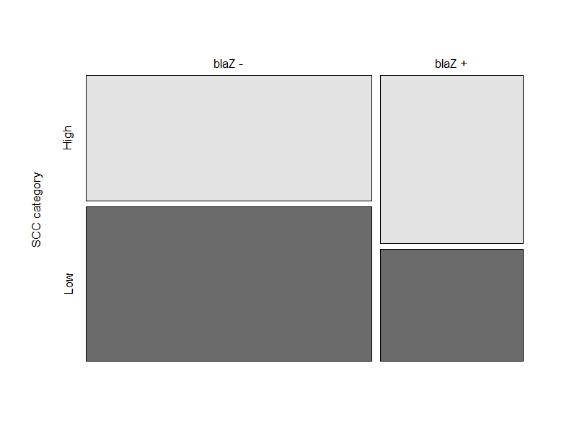

**n = 9**

**n = 11**

**n = 6**

**n = 4**

Figure 1.Carriage of the *blaZ* gene (encoding for the production of beta-lactamase) for 30 *Staphylococcus chromogenes* isolates from subclinical bovine intramammary infections by SCC category. All isolates in the HIGH category (n = 15) come from IMI which had an SCC of ≥200,000 cells/mL associated with all quarter-day observations, and all isolates in the LOW (n = 15) category come from IMI which had an SCC of <200,000 cells/mL associated with all quarter-day observations.

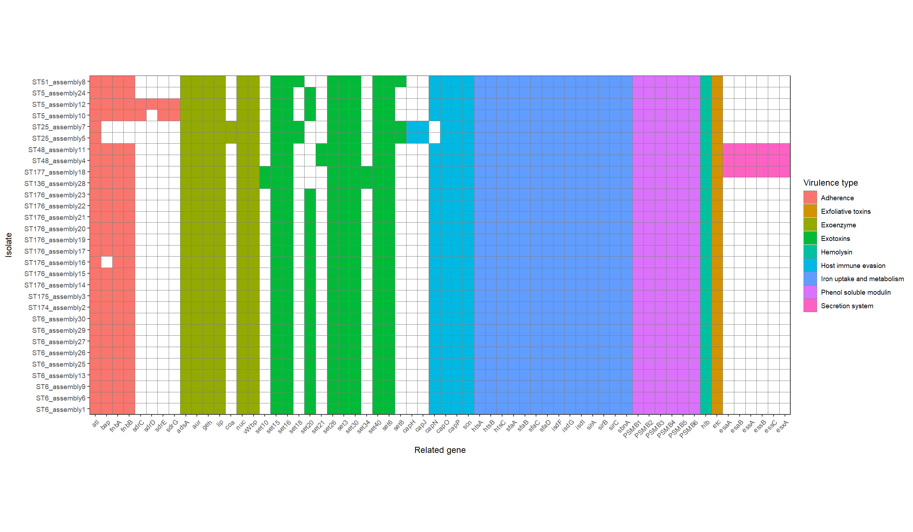

Figure 2.Distributions of putative virulence genes for 30 *Staphylococcus chromogenes* isolates from subclinical bovine intramammary infections by virulence type. Isolates of the same strain type (ST; determined by multilocus sequence typing) are listed sequentially. Scheme for grouping putative virulence genes by type adapted from Naushad et al., 2019.

Figure S1. Dendrogram constructed from concatenated nucleotide sequence data for the 20 study isolates as well as 386 publicly-available concatenated MLST sequences for Staphylococcus chromogenes. Study isolates which grouped together with a bootstrap value of ≥ 65% were classified as ST clusters, and are highlighted by a red rectangle. The tree was constructed using a maximum-likelihood algorithm with the optimal model and 100 bootstrap replications in MEGA-X (Kumar et al., 2018).